Gold Master fixes, Level 1

A: Rooms need a system to inform the player which way they’re supposed to go. I will be fixing this with the signs we have, but textured red for wrong way, and green for right way. I’ll have them at different points in the map at doorways and such. -Sam

~~A: this happens, where all these guys get stuck on the wall and don’t know what to do. First room. The guy on the box is also stuck and just running in place. They will still shoot, but at a much more reasonable rate than earlier version. -Anthony~~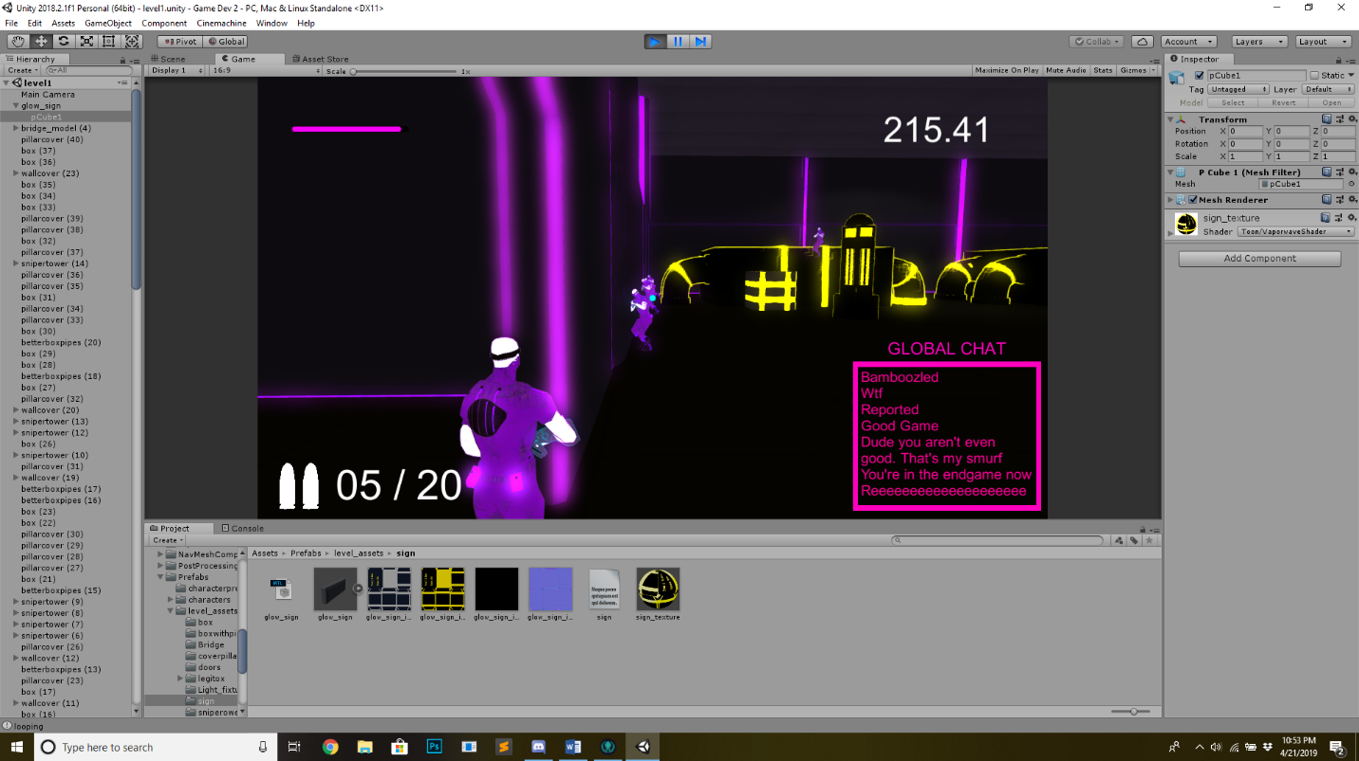

A: if we have recoil, then the gun should return to where it was, not slightly above. It’s not really immersive, it’s just annoying to deal with. –Steve

~~A: should respawn as the last guy you were. I hate getting to be the hunter, and then dying immediately, no being able to play said hunter at all.~~

B: shooting with the normal grunt feels kinda off. The shots appear to land but don’t, especially when you are trying to peak a corner or are close to a wall. Either that, or the grunts take more shots than I initially remember. If it is just that you don’t deal a lot of damage as a grunt, then we might want to consider increasing that damage. Not as a, we need more damage, but as a hypothetical test to see which we like more. -Steve

B: The enemy grunts in the first hallway still run right into the wall and get stuck on the first obstacle and the wall, forever running in place and unable to move. –Anthony

B: Guy on the big pipe box in the center of the first room glitches out horribly and starts moving between two spots very fast, causing a blurring effect. -Anthony

B: this happens more often than it should with walls

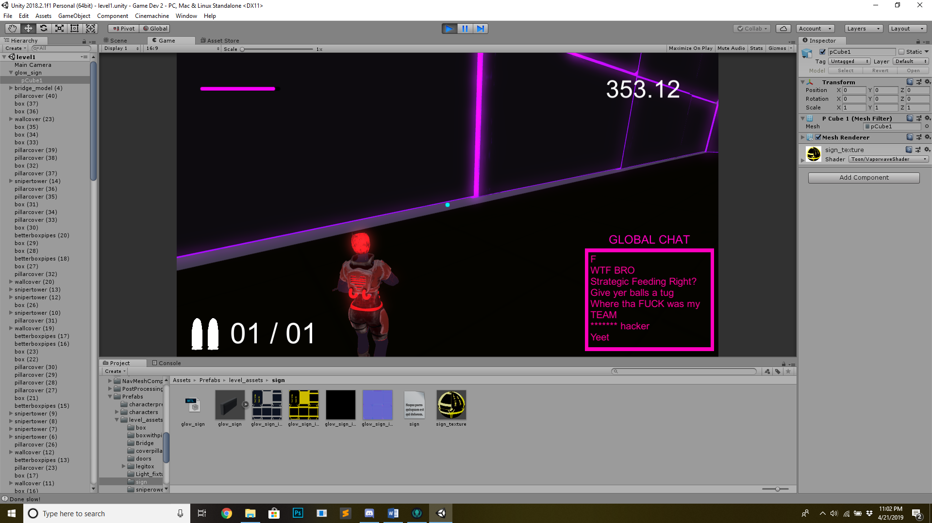

~~B: sniper’s jump is really finicky. It sometimes works, but then refuses to work after a few jumps. -Steve~~

C: why does the player spawn facing the left of the first hallway? It would make more sense to start facing the hallway. Minor tweak for later if we have time. –Steve

C: if you look straight up, the camera starts to violently vibrate. We’re talking the flash vibrating his molecules level of shaky. Not a huge deal, but something we might want to fix up if there’s time. Edit, this happens at certain sweet spots, I.E whenever the camera’s position in the game is essentially in the wall. -Steve

C: side walls in the first hallway need to be lowered. They are currently floating slightly above the floor. –Bryce.

~~C: as a possessed grunt, you can sometimes start running, stop, and the animation for running will continue to play. -Steve~~

C: for the ending of level 1, you can clip through the wall to get the magic doorway place. Specifically the wall right next to it. –Steve

Level 2 fixes:

A: Enemies will regularly clip through objects, which leads me to believe that Anthony needs to remake the navmesh for this second level.

~~A: okay, this guy gets stuck in this big box in the second room. -Anthony~~

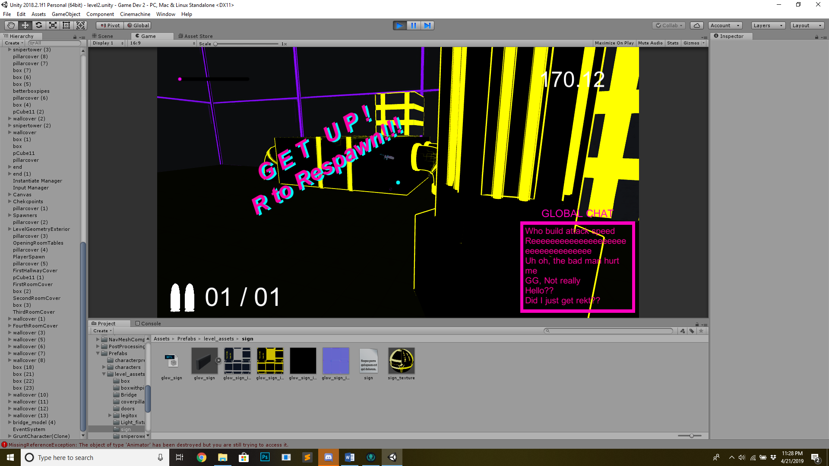

A: heavy’s gun doesn’t exist for some reason. He can’t fire, and I don’t think the enemies can even shoot at you. Also, the shield looks like it’s only in front of you and slows you down, which is terrible. ~~Please make him smaller too, he is way too big for the level right now~~. –Bryce/Steve

A: Stairway in the last big room needs a hit box on it, right now you can walk right through it.-Bryce/Sam.

A: All bridges in level 2 need colliders. The two in the next half of the last room are also nonexistent in terms of tangibility. Bryce-Sam.

~~A: Final red room doesn’t take you to the final boss. I thought we were doing that but if we aren’t, then this isn’t as big of an issue. As of now though, it doesn’t even trigger anything, not even a cutscene.~~

A: Also, he will do this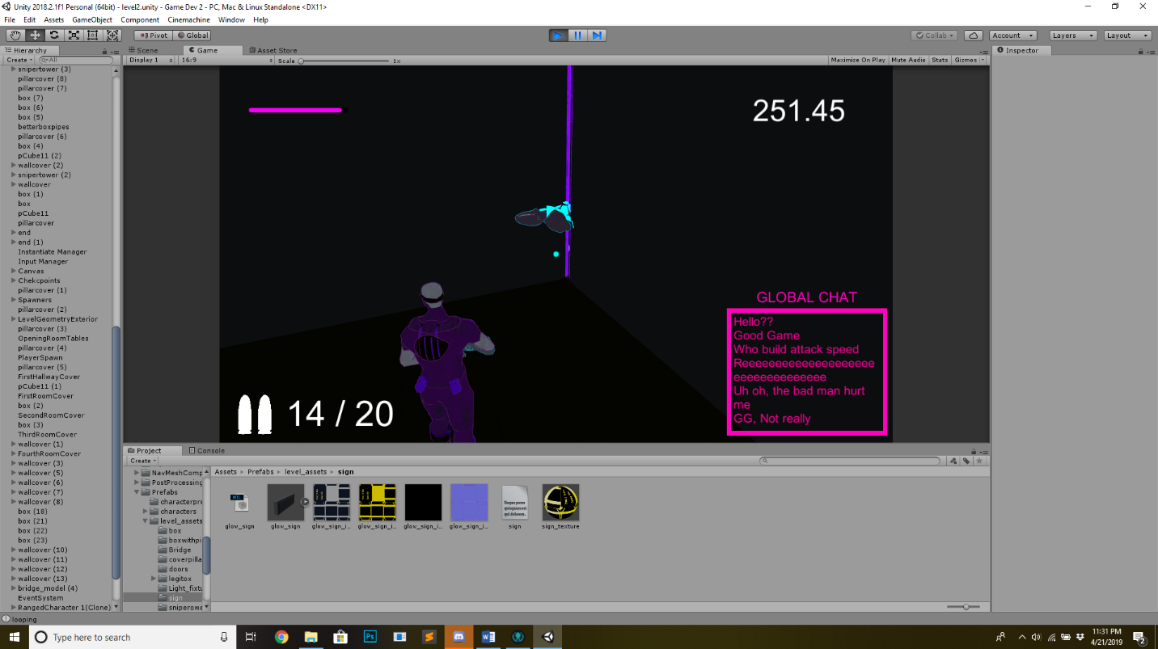

There he goes into the ether, never to be seen again. -Anthony

A: If you die during time stop as a sniper, and respawn as normal guy, you never come out of slo-mo. -Steve

B: Sniper enemies need to move the same speed as the grunts and they need to die in fewer hits. They should not need two shots to kill while playing as a sniper. -Steve

B: DO NOT POSSESS AN ENEMY FALLING OUT OF THE MAP. Also, in case we do fall outside the map, can we have a safeguard to respawn the player? I feel like that would make things a simpler, especially playtest-wise. –Anthony(this is really just a pathing issue.

B: the texture on these boxes come off the actual object, specifically the yellow stripes. –Bryce

C: First half of the last room feels like it has a bit too many enemies in it. Move some of them to the second half since that side doesn’t have any enemies at all in it. -Steve

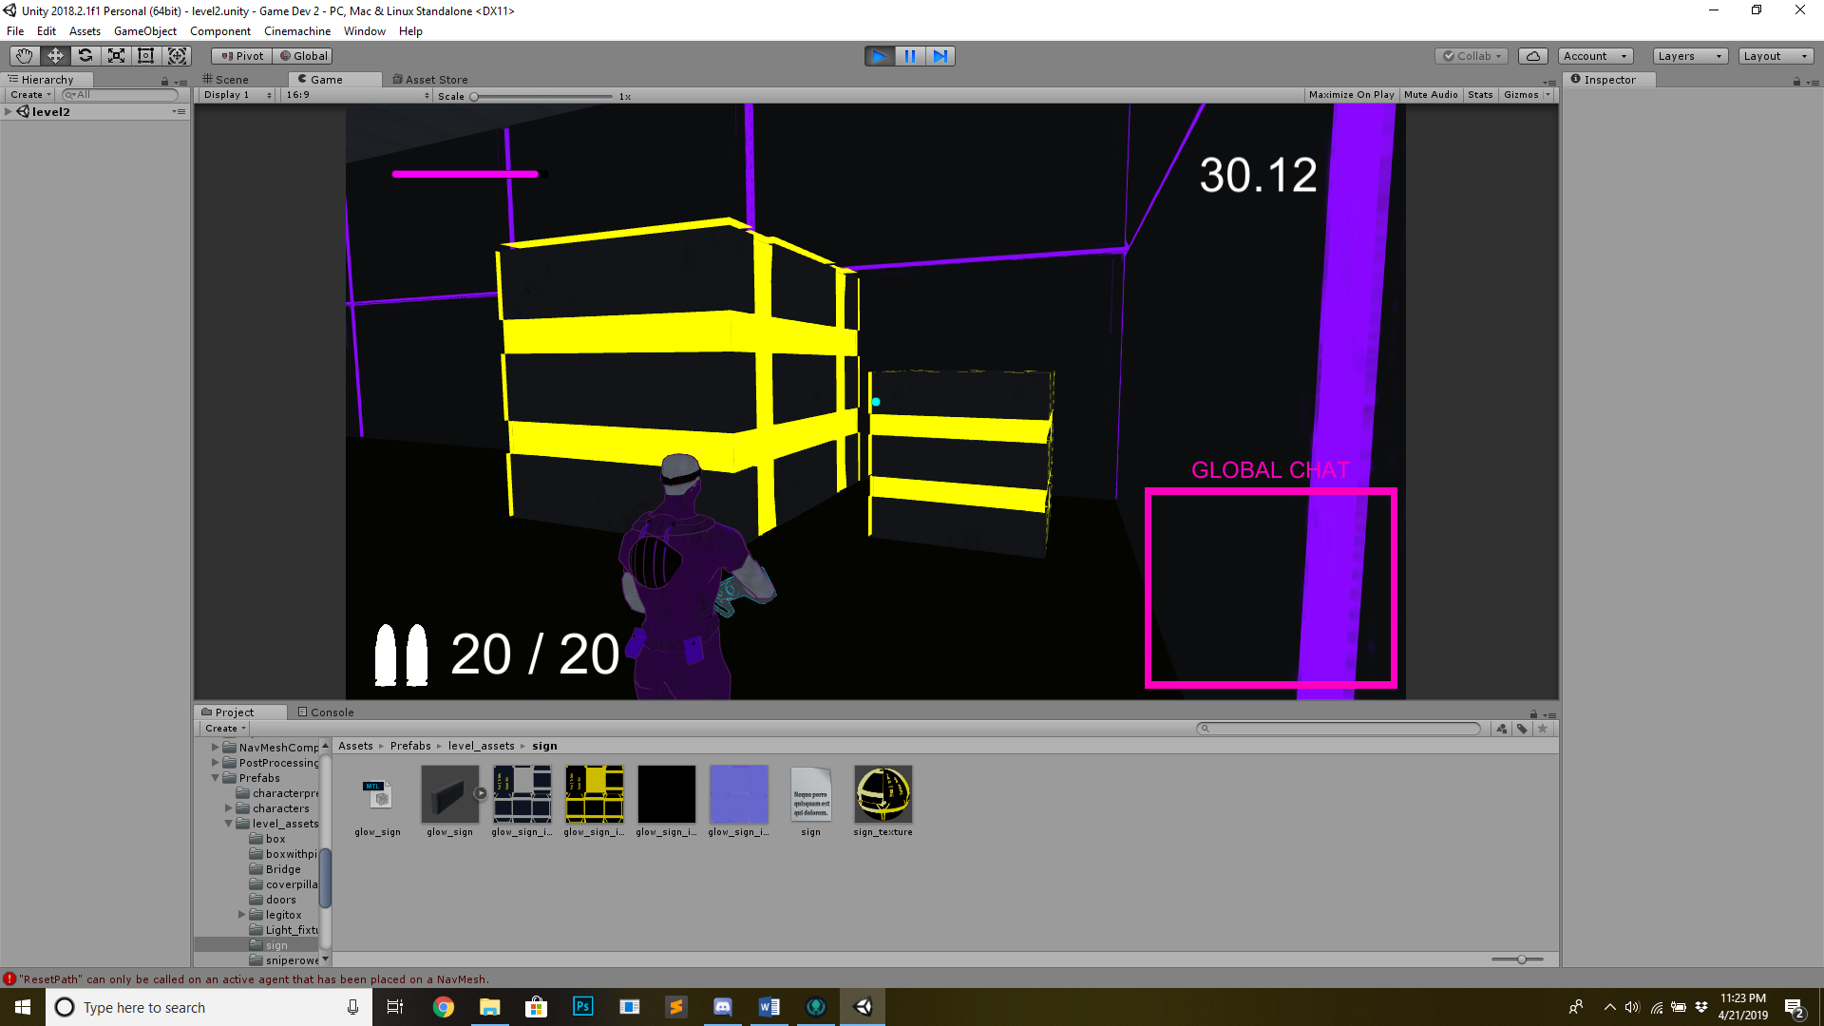

B: grunts have trouble getting back into the first hallway if they enter the starting room, and the first sniper to spawn doesn’t really interact with player at all, making it a little too easy.

B: if the camera is in that weird spot where it’s close to the wall, sniper refuses to aim down sights at all. –Steve

B: Sniper needs to reload faster. He’s firing a bolt action rifle semi-auto, not a musket. -Steve